Topic Covered Till 23-September-2020

**1) Types of decision**

Low Level – TPS/OLTP (Routine level Decisions)

Middel Level – MIS

Top Level – DSS/OLAP (Strategic Level Decisions)

**2) Types of Data**

Structured (Excel)

Semi – Structured (XML, email)

Unstructured (PDF, Images, Powerpoint)

**3) Meaning of Data Warehouse**

**Subject oriented, integrated, time variant, non volatile collection of data**

**As per Bill Inmon approach**

**4) Difference between OLTP and OLAP**

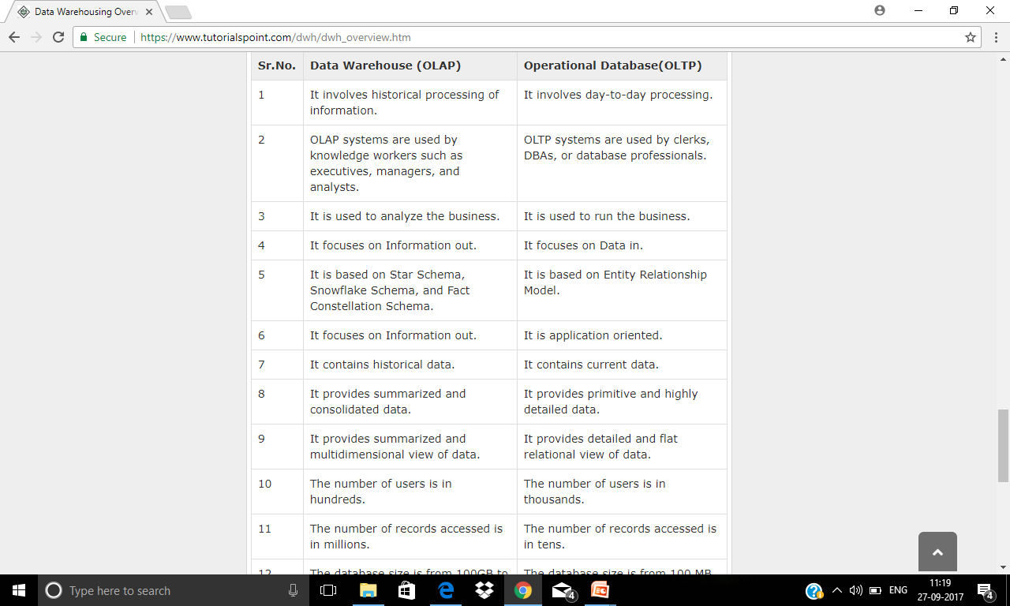

**5) Granularity of data**

**High Level of Granularity mean low level of data (detail)**

**Low Level of Granularity means high level of detailed data**

**Inversely proportional**

**Should be defined before discussing the point of analysis**